External Contractors and Telecommunications Service Providers Installation and Access Guidelines

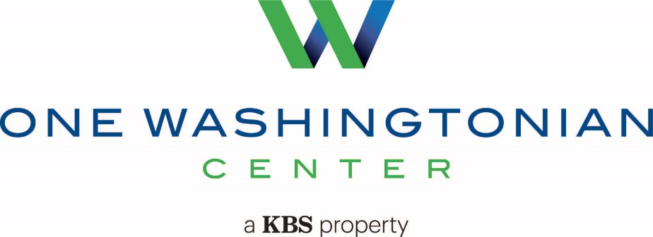

9801 Washingtonian Boulevard
Gaithersburg, MD 20878

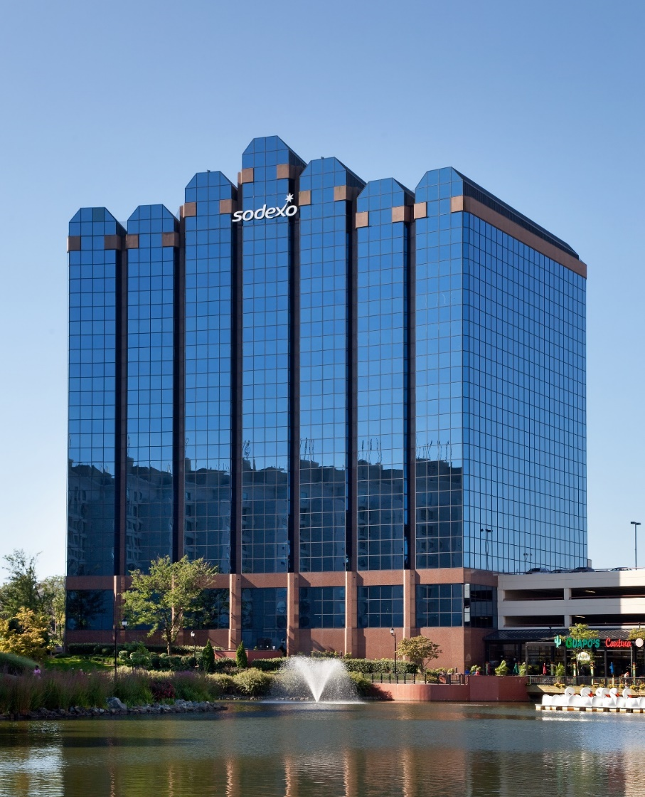

The purpose of this document is to provide information to contractors and building occupants about our building vendor standards, tenant connectivity guidelines, and services within the building’s-maintained riser. This document also sets the standards for the installation and abatement of riser cable and equipment at Building. It is not intended for this document to replace the standards set forth in the Construction and/or Building Rules and Regulations. Rather, this is a quick overview of our building vendor standards and tenant connectivity guidelines. All documentation generated through these standard processes shall be the sole property of the building and shall remain within the building for future reference.

Building Directory:

Deidre Proffitt
Sr. Property Manager
240.399.0570
Deidre.proffitt@transwestern.com

Keisha Walker
Asst. Property Manager
240.399.0571
Keisha.walker@transwestern.com

Pat Chroniger
Chief Engineer
202-498-4418
Pat.Chroniger@transwestern.com

One Washingtonian Access Procedures

General Access:
Weekends and holidays buildings is on restricted access status. Access card is required.

Management Office Hours:
Monday - Friday
8:00 AM to 5:00 PM

Building Hours:
Monday - Friday
7:00 AM to 6:00 PM

Security Staff Hours:
24hrs/7 days per week
Desk 301.990.1036
Mobile 301.399.6725
Loading Dock and Freight Elevator Hours:

Monday - Friday
6:00AM to 6:00 PM

*Please note that the loading docks are used for active loading/unloading only. After completing the loading/unloading process, vehicles should be immediately removed from the loading dock. Parking is available on the surface parking lot area in the front of the building. All loading docks are frequently used daily during business hours for deliveries.

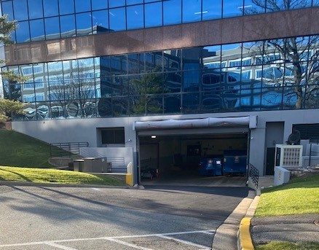

We must ensure that any contractors; including sub-contractors, support personnel, or any other service personnel have their current Certificate of Insurance on file. All scopes of work must be submitted and formally approved by management prior to arriving onsite. You must submit your COI to the management office for approval.

Please provide the below information to the building manager:

The required elements should include:
- First/Last Names of all participants
- Company Name
- Date and time of arrival
- Purpose of the Work
- Type of work that will be conducted
- Estimated time needed to complete work
- Affected locations for the work
- Access requirements
- First/Last Names + Contact information of the Field Engineer on-site

All scopes of work must be submitted and formally approved by management prior to arriving onsite.

Building COI requirements:

Insured:
One Washingtonian Center
9801 Washingtonian Blvd
Gaithersburg, MD 20878

Required Coverages:

Commercial General Liability (CGL): | $1,000,000 per Occurrence and  $2,000,000 Aggregate for Bodily Injury, Personal Injury, Property Damage, and Products/Completed Operations, and shall be written on a primary and non-contributory basis over any liability policy carried by OWNER, OWNER’S REPRESENTATIVE and PROPERTY MANAGER and include an endorsement clarifying such position if the base policy does not include equivalent language, for all claims or liabilities arising from, or incidental.
Commercial Automobile: | $1,000,000 each occurrence Liability Insurance combined single limit for bodily injury and property damage. Evidence should indicate that liability coverage evidenced extends to both owned, hired, and non-owned vehicles.
Umbrella Liability: | $1,000,000 minimum except $5,000,000 for those services that can be defined as structural, mechanical, roofing, or remediation work. Such insurance shall be in excess of all liability coverage required.
Worker’s Compensation: | Statutory Amount
Employer’s Liability: | $1,000,000 minimum
Professional Liability Insurance Coverage: | (Architects, Consultants and/or Engineers only): If requested, $2,000,000 or project dollar amount.
Fidelity Bond (which includes employee dishonesty coverage): | Limits in an amount not less than the Dollar Amount of the Project (Or other if agreed to by Owner) for all employees of Vendor.  ****This is ONLY required if Vendor is handling, managing, or processing of any of the project’s monetary funds for OWNER or for Janitorial or other like services where vendor is inside premises unsupervised during non-business hours. ***

Required Endorsements:

Additional Insured Endorsement: | Additional Insured endorsement to the CGL, Auto and Umbrella Liability policies should be provided in favor of Owner, Owner’s Representative and Manager.
Waiver of Subrogation Endorsement: | Waiver of Subrogation endorsement to the CGL, Worker’s Compensation & Employer’s Liability policies should be provided in favor of Owner, Owner’s Representative and Manager.
Cancellation Notice: | Policies will include a cancellation clause providing that such insurance may not be cancelled, lapsed, reduced or materially changed without 30-days written notice to the Owner, Owner’s Representative and Manager.

Endorsements must read:
“Prime US-One Washingtonian, LLC, KBS Realty Advisors, LLC and Transwestern Carey Winston LLC dba Transwestern are named as additionally insured as regards to premises located at One Washingtonian Center, 9801 Washingtonian Blvd., Gaithersburg, MD 20878. All rights of subrogation against Prime US-One Washingtonian, LLC, KBS Realty Advisors, LLC and Transwestern Carey Winston, LLC, dba Transwestern are hereby waived.”

Certificate Holder must read as follows:

Prime US-One Washingtonian, LLC
c/o Transwestern Carey Winston, LLC
9801 Washingtonian Boulevard
Suite LL004
Gaithersburg, MD 20878

Additional insured to be listed as follows:
1) Prime US-One Washingtonian, LLC
2) KBS Realty Advisors, LLC
3) Transwestern Carey Winston, LLC

Email Address for COI: Keisha.walker@transwestern.com

All insurance carriers must have a minimum AM Best rating of A-:VII.

Operations and Installation Procedures in the Building

Outline the process for obtaining approval to conduct installations within the building
- All scopes of work must be submitted and formally approved by Management prior to arriving onsite. You must submit your COI to keisha.walker@transwestern.com for approval.
- All core drills within the building require x-ray scan and approval from a structural engineer of your choice. This is a post-tension building.
- You must provide evidence of approval and schedule work with the Chief Engineer – pat.chroniger@transwestern.com.

Outline Building Access Restrictions
- All vendors must check in with security in the main lobby upon arrival.
- 48 hours’ notice required for Freight and Loading Dock Access.
- All approved vendors and tradesmen shall enter loading dock only and use freight elevators only.
- Equipment installations can be completed during normal business hours. Any loud noises or drilling must be completed before 8:30am or after 6:00pm, M-F or weekends.

Tenant Access Restrictions
- Riser closets for the building are centrally located in the core of the building. Closets are secure and can only be accessed by authorized personnel.

Technical Information

Points of Entry:
The main points of entry are located along Washingtonian Boulevard.

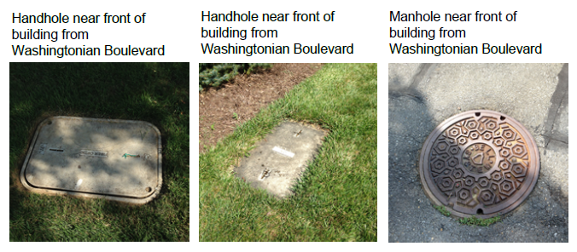

As well as the Main Electric Room and Main Telephone Room in the Lower Level of the Building:

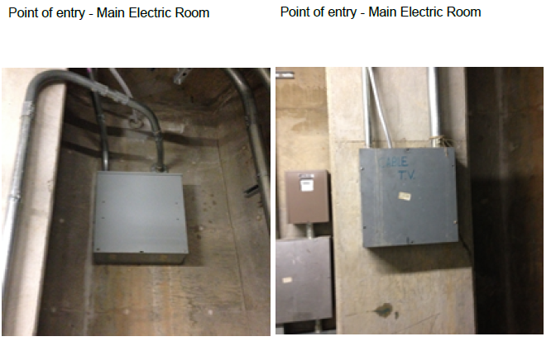
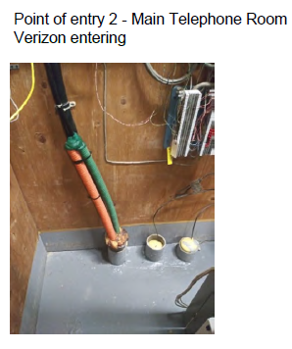
Basement Schematics:
The Main Telco Room is located in the Lower Level of the Building. See Below Diagram.

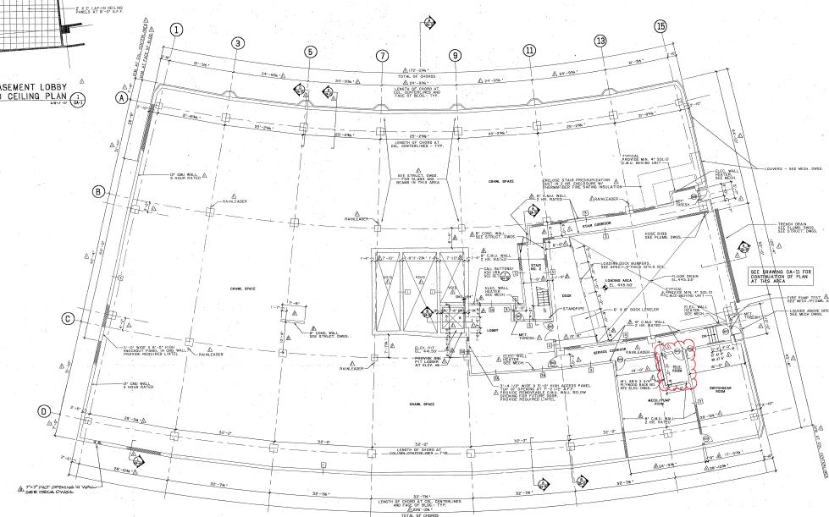

Horizontal Pathway Specification:
The path from the points of entry travels in conduits from the Main Electric and Telephone Rooms along the ceiling to the Risers which are centrally located in the core of the building.

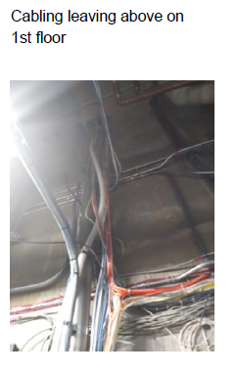

Telecom Equipment Room Specifications:
Riser closets for the buildings are centrally located in the core of the building. Closets are secure and can only be accessed by authorized personnel.

Riser Stack Plan:
All riser rooms are stacked directly above each other. The only offset is from the lower level to the first floor (points of entry to riser). They are shown in red on the below diagrams.

Lower level:

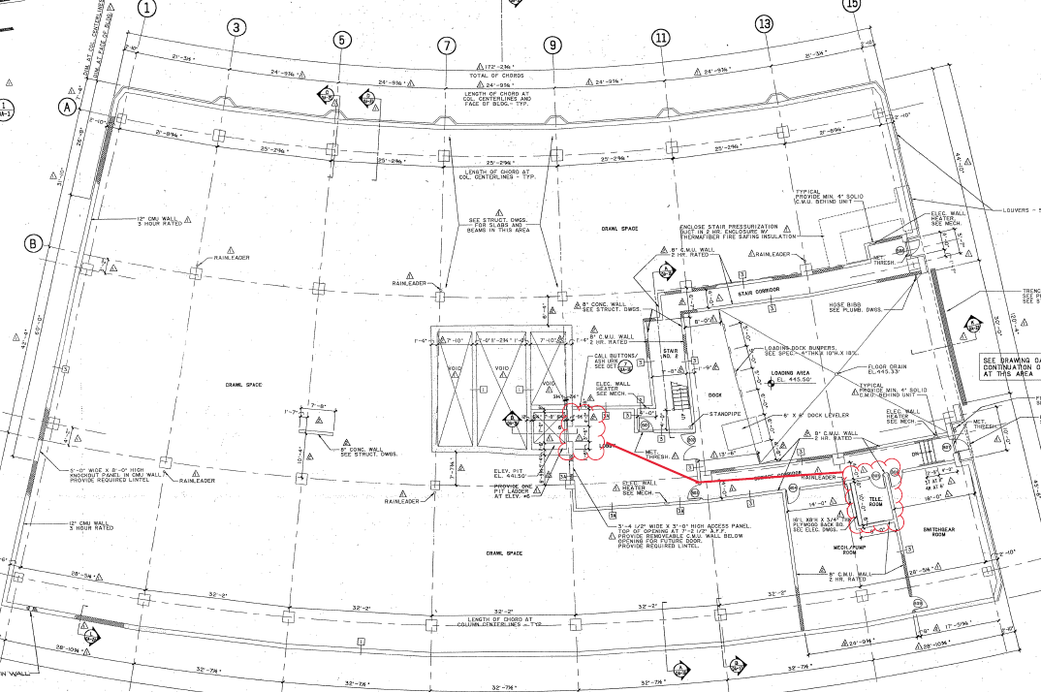

First floor and above:

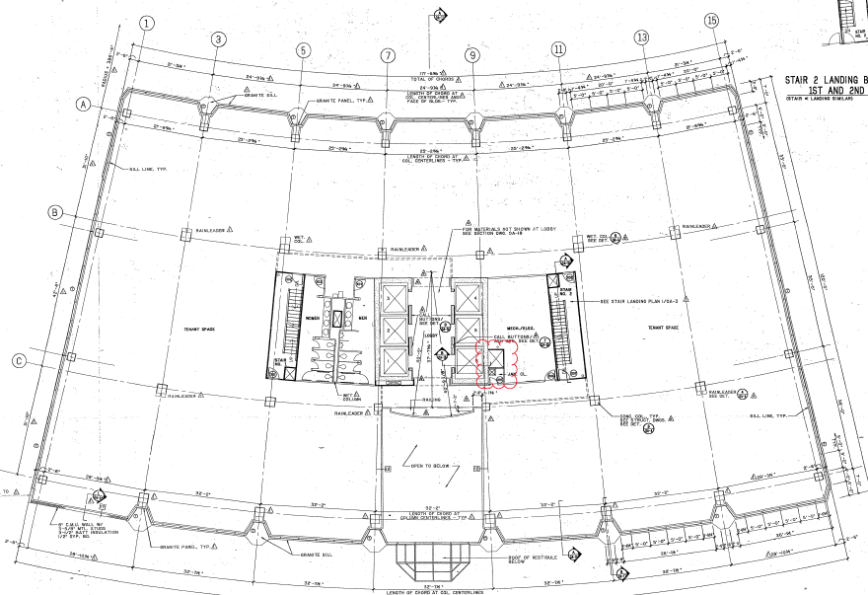

Riser Specifications:
All cables must be labelled throughout the riser for identification. Any core drilling must be x-rayed and approved by management and a structural engineer.

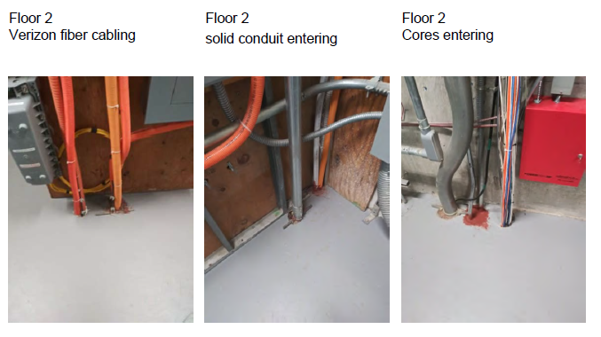
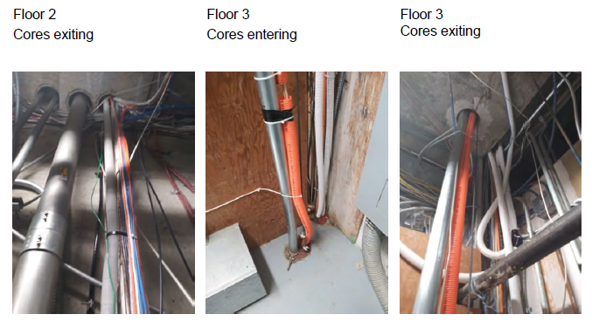

Specifications for cable runs from the riser:
Cable must be plenum rated and securely hung by hangers.

Installation Codes:
Cable must be plenum rated and securely hung by hangers. Must be compliant with City of Gaithersburg, MD code.

Project Closeout Requirements:
- Once complete full as-built drawings must be submitted to property management
- Contractors are to take all waste materials with them and properly dispose.

